The Book of
Revelation
Lesson Number Eight

“Walk Through the Bible” Series
© 2016 by Jay S. McMullan

Study Guide
Message to the Pastor at Laodicea

This was the last of the letters to the seven Churches.

Revelation 3:14-22 (NLT)
¹⁴ “Write this letter to the angel of the church in Laodicea. This is the message from the one who is the Amen—the faithful and true witness, the beginning of God’s new creation: ¹⁵ “I know all the things you do, that you are neither hot nor cold. I wish that you were one or the other! ¹⁶ But since you are like lukewarm water, neither hot nor cold, I will spit you out of my mouth! ¹⁷ You say, ‘I am rich. I have everything I want. I don’t need a thing!’ And you don’t realize that you are wretched and miserable and poor and blind and naked. ¹⁸ So I advise you to buy gold from me—gold that has been purified by fire. Then you will be rich. Also buy white garments from me so you will not be shamed by your nakedness, and ointment for your eyes so you will be able to see. ¹⁹ I correct and discipline everyone I love. So be diligent and turn from your indifference. ²⁰ “Look! I stand at the door and knock. If you hear my voice and open the door, I will come in, and we will share a meal together as friends. ²¹ Those who are victorious will sit with me on my throne, just as I was victorious and sat with my Father on his throne. ²² “Anyone with ears to hear must listen to the Spirit and understand what he is saying to the churches.”

Jesus refers to Himself differently in each letter to the Churches. Jesus _______________ different aspects about Himself to us through these references.

Ephesus - the one who holds the seven stars in his right hand, the one who walks among the seven gold lampstands.
Smyrna - the one who is the First and the Last, who was dead but is now alive.
Pergamum - the one with the sharp two-edged sword.
Thyatira - the Son of God, whose eyes are like flames of fire, whose feet are like polished bronze.
Sardis - the one who has the sevenfold Spirit of God and the seven stars.
Philadelphia - the one who is holy and true, the one who has the key of David.
Laodicea - the one who is the Amen—the faithful and true witness, the beginning of God’s new creation.

Laodicea was a city located west of Colossae in an area called __________________. Other cities in this region were Antioch in Pisidia, Colossae, Hierapolis and Iconium.

East of Phrygia was the area of _____________________. These were like counties.

Other regions around Phrygia, where churches had already been established at this time were Galatia, Pisidia, Pamphylia and Lycaonia (Lycia).

Rev. 3:14
What does it mean when Jesus says He is the one who is the Amen—the faithful and true witness, the beginning of God’s new creation.

Amen – Literally means “Yes,” “Verily” which basically means Jesus is the ____________!

2 Corinthians 1:20 (NLT)
²⁰ For all of God’s promises have been fulfilled in Christ with a resounding “Yes!” And through Christ, our “Amen” (which means “Yes” or “truth”) ascends to God for his glory.

[beginning of the creation of God] That is, the One who began creating all things in the very beginning (Jn. 1:3; Eph. 3:9; Col. 1:15-18; Heb. 1:2; 11:3). It _______________ _________ mean that He was the first to be created by God, for He is an uncreated and eternal being (Isa. 9:6-7; Mic. 5:2; Jn. 1:1-2; Heb. 1:8; Rev. 1:8, note).
Dake's Annotated Reference Bible: Containing the Old and New Testaments of the Authorized or King James Version Text.

Rev. 3:15, 16
The first thing Jesus said to the Laodiceans was, “I ______________ all the things you do!”

Jesus said this to ______________ one of the seven churches!

What else did Jesus say to each of the seven churches?

“Anyone with ears to hear must listen to the Spirit and understand what he is saying to the churches.”
- What does this mean?

Jesus said that the Laodiceans _____________ they were rich but in fact, were wretched and miserable and poor and blind and naked.

The people in the Church in Laodicea were exactly the __________________ of what they _____________ they were!

Five things about the Church in Laodicea:

- Jesus knew their works.
- They were neither hot nor cold.
- Lukewarm and nauseating to the Lord.
- Proud and self-satisfied.
- They were not aware of their true state.

Jesus gives advice to the Church in Laodicea. In other words, He is giving advice to each person in the Church! The Church IS the ___________________!

4 Things God advises the Laodiceans to do:
- Buy refined gold from Him so they could ______________ be rich
- Buy white garments from Him so they would not be ___________________.
- Buy ointment from Him for their eyes so they could ___________.
- Be diligent (KJV says “zealous”. Means to be “hot” or “________________.”

Exodus 34:14 (NLT)
¹⁴ You must worship no other gods, for the LORD, whose very name is Jealous, is a God who is jealous about his relationship with you.

One of God’s names which reveals His _________________ is in Hebrew “el Qanna” or “Jehovah Qanna.” This means God is Jealous just like “el Rapha” means God our Healer, “el Jireh” means God our Provider, etc.

Rev. 3:20
Jesus desires to have _______________ fellowship with us.

1 Thessalonians 5:16-22 (NLT)
¹⁶ Always be joyful. ¹⁷ Never stop praying. ¹⁸ Be thankful in all circumstances, for this is God’s will for you who belong to Christ Jesus. ¹⁹ Do not stifle the Holy Spirit. ²⁰ Do not scoff at prophecies, ²¹ but test everything that is said. Hold on to what is good. ²² Stay away from every kind of evil.

Praying is, in its most simple term, __________________________ with the Lord!

Jesus wants us to be ____________________________!

What Jesus said to each of the Churches concerning us as Overcomers.

Ephesus (Rev. 2;7) - To everyone who is victorious I will give fruit from the tree of life in the paradise of God.
Smyrna (Rev. 2;11) - Whoever is victorious will not be harmed by the second death.
Pergamum (Rev. 2:17) - To everyone who is victorious I will give some of the manna that has been hidden away in heaven. And I will give to each one a white stone, and on the stone will be engraved a new name that no one understands except the one who receives it.
Thyatira (Rev. 2:26-28) - To all who are victorious, who obey me to the very end, To them I will give authority over all the nations. They will rule the nations with an iron rod and smash them like clay pots. ²⁸ They will have the same authority I received from my Father, and I will also give them the morning star!
Sardis (Rev. 3:5) - All who are victorious will be clothed in white. I will never erase their names from the Book of Life, but I will announce before my Father and his angels that they are mine.
Philadelphia (Rev. 3:12) - All who are victorious will become pillars in the Temple of my God, and they will never have to leave it. And I will write on them the name of my God, and they will be citizens in the city of my God—the new Jerusalem that comes down from heaven from my God. And I will also write on them my new name.
Laodicea (Rev. 3:21) - Those who are victorious will sit with me on my throne, just as I was victorious and sat with my Father on his throne.

How can we be Overcomers and be Victorious in this life?

Jesus overcame the world! (John 16:33)

The Bible tells us that the servant is not greater than the master. We are to be overcomers like Jesus! (John 15:20)

The Key to Overcoming in this Life

Revelation 12:11 (KJV)
¹¹ And they overcame him by the blood of the Lamb, and by the word of their testimony; and they loved not their lives unto the death.

Homework:
- This week, take the time to write out your testimony.
† How did you hear about Jesus and His sacrifice for you?
† How has your life changed since you were saved?
- Next, answer these questions.
† Have you suffered persecution for being a Christian?
† Is there any specific thing you have learned that has made your Christian experience easier?

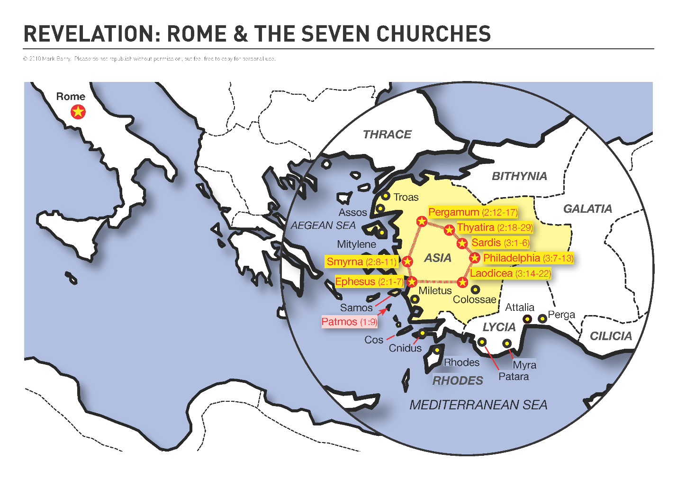
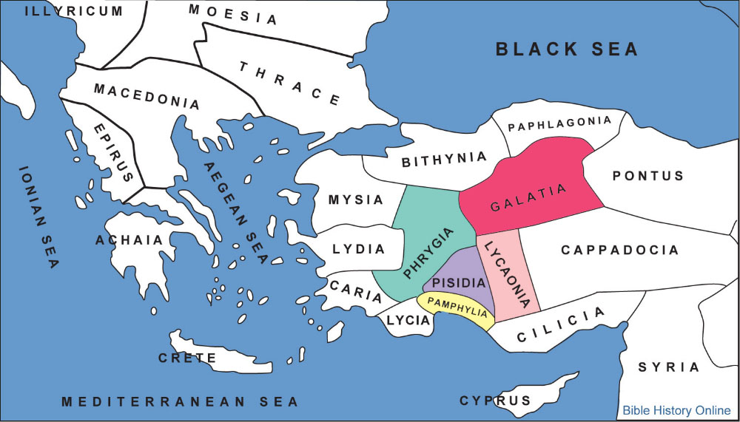
At the time of the writing of Revelation, Churches had been established in the regions of Phrygia, Pisidia, Pamphylia, Lycaonia and Galatia.
http://www.JayMc.com/truthsowers/lessons/Revelation/Images/AsiaMinorMap.docx

